**GPGN 558: Seismic Interpretation**

**3D Seismic Interpretation of Forties Field**

**Due: 03/21/2019**

**Group 3:**

Rosie Zhu

Nadima Dwihusna

Kyle Fry

**Executive Summary**

Team 3 is tasked with interpreting a 3-D seismic survey from the Forties Petrel Project in the North Sea from BP. An interpretation of an accurate depositional model is the key to obtain reliable results in reservoir simulations. The submarine fan environment of the Forties Field is complex, contains abrupt transitions from channels and lobes to interchannel facies in terms of bed thickness, net/gross ratios, and shale distributions. The overall mapping of sandstone distribution in channel-fill and lobe sequence will provide a good foundation for reservoir simulation. Time-series and seismic attribute maps are used to illustrate the field subsurface structure and stratigraphy to identify the potential petroleum prospect for exploration. The Seismic Interpretation software package is utilized within Petrel 2017 for this project. Initial seismic interpretations are made from a digital well log with given horizon names and are correlated onto the Inline 2-D section of the seismic survey data.

The team decided to focus on the top of the Forties Sandstone Formation interval (Upper Forties Charlie Sand Unit) with a high resistivity and low water saturation value indicating oil reservoir. A general area of interest was determined to be in the west part of the survey area which is interpreted to have an anticlinal structure and thickening the sandstone interval as shown in the isochron map of the reservoir. The eastern side of the anticline shows lower RMS velocities while faster than water also indicating high potential as an oil prospect. From an in depth assessment of the area the reservoir has high potential of producing between 17 MMbbl to over a 100 MMbbl of oil over its lifetime netting between $1B to $7B. Some of the risks involved include compartmentalization of the reservoir from unexpected faulting. The P90 region is promising with a thick payzone that thins out some when moving away from this spot.

1. **Introduction**

The company has recently acquired the the 3-D survey from the Forties Petrel Project in the North Sea from BP. Team 3 has been selected to interpret a new promising potential petroleum reservoir prospects in the region. The figure 1 below represents the exploration project workflow the team has accomplished outline in this report. The first step is to develop a geologic framework identifying the major faults, unconformities and stratigraphic packages in the area to understand the geological and tectonic history. The second step is to analyze both the well logs, seismic volume and attribute maps, and interpreting seismic horizons to identify the key packages of the potential reservoirs and source rocks. The third step is to identify the potential area and the prospect elements (source, migration, reservoir, and trap) through seismic attributes and propose the final drill site to management. The final step includes a reservoir de-risking assessment identifying the reserve estimates and economic analysis (Low P10, Mid P50, High P90 Cases) tied to the seismic data.

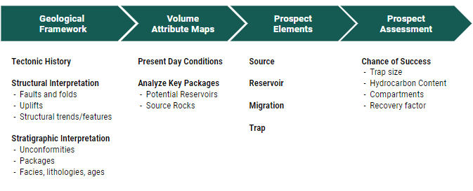

Figure 1: Seismic Exploration Workflow [2].

1. **Geological Framework**
   1. **Survey Location**

The Forties field is located in the North Sea approximately 180 km east-northeast of Aberdeen and lies in the UK License Block 21/10 and discovered by British Petroleum BP in the Paleocene sandstones of the Forties Formation. The figure 2 below represents the upper Paleocene unit of the Central Graben. The sandstone reservoir of the Forties Field formas part of a major submarine fan-body which covered the Central Graben area of the North Sea basin during the Paleocene. The sediment source for the Forties submarine fan moves from the north west as seen by the arrows in the figure.

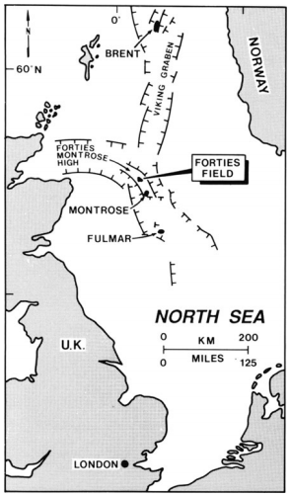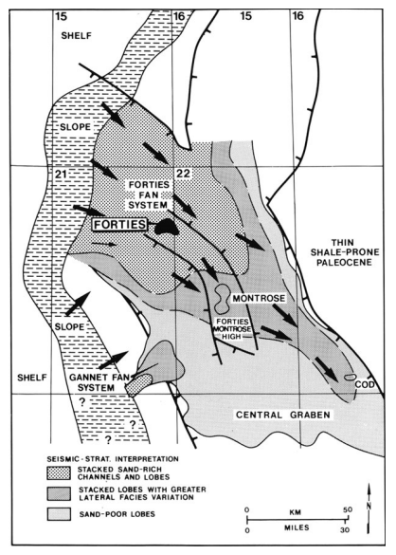

Figure 2: Forties Field Survey Location *(left)* and Upper Paleocene Central Graben *(right)*

* 1. **Depositional and Tectonic History**

The submarine fan environment of the Forties Field is complex, contains abrupt transitions from channels and lobes to interchannel facies of sandstone distribution in channel-fill and lobe sequence. There are three distinct fan-lobe sequences prograded south and southeastward during palynological time. From East to west, the fan-lobes are Charlie, Main, and S.E Forties Sands which can be seen in the time structure and coherency map in Figure 7.. These channel system acts as major sediment deposition and shifted continuously throughout the Forties Formation [5] as seen in figure 3 below.

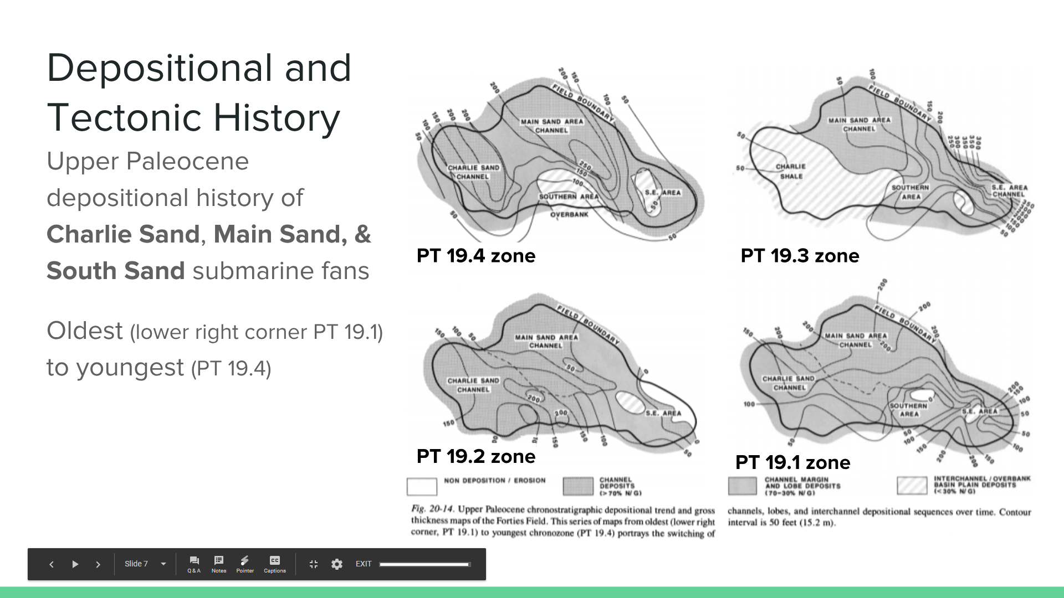

Figure 3: Forties Upper Paleocene depositional history of Charlie, Main, and South Sand submarine fans from oldest (lower right corner PT 19.1) to youngest (PT 19.4) [5].

The lithostratigraphy and structural settings subdivides the Paleocene/Eocene sandstones and shales of the field. The Forties Formation is divided into a lower interbedded sandstone, shale, and limestone sequence. Additionally, the Sandstone is further divided into two sand units, the Main Sand unit and the Charlie Sand Unit, separated by the Charlie Shale unit. This Sandstone Member which contains the most of the Forties oil which represents the reservoir interval as seen in the Figure 4 below. The Figure 5 below represents the overall stratigraphic thickness of the upper Forties Charlie Sand Unit and the Figure 6 below also represents the overall stratigraphic thickness of the lower Forties Main Sand Unit from Northeast to Southwest. Overall, the Forties Charlie Sand Unit shows a thicker sand reservoir interval.

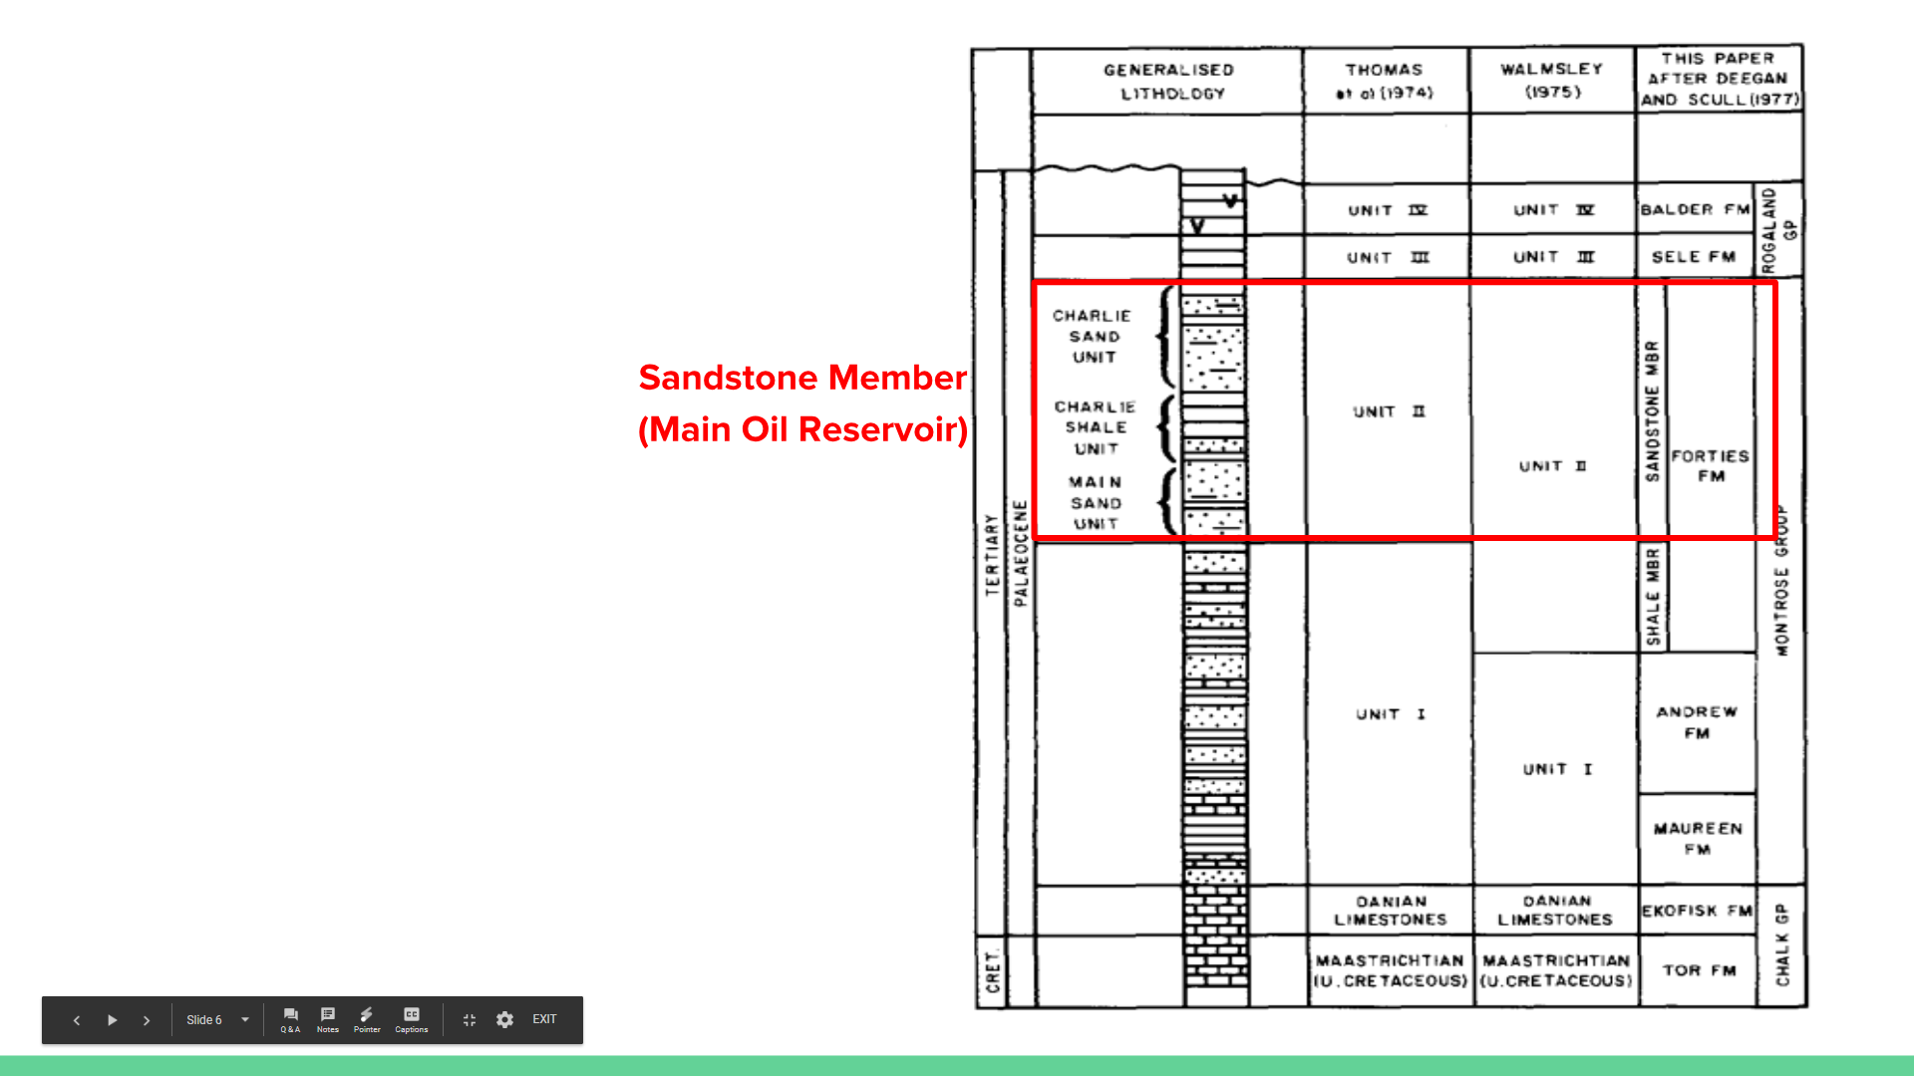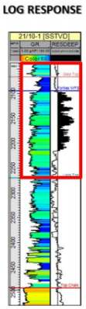

Figure 4: Early Paleogene lithostratigraphic nomenclature of Forties field *(left)* [3]

and typical log response of the Forties Sequence *(right)* [4].

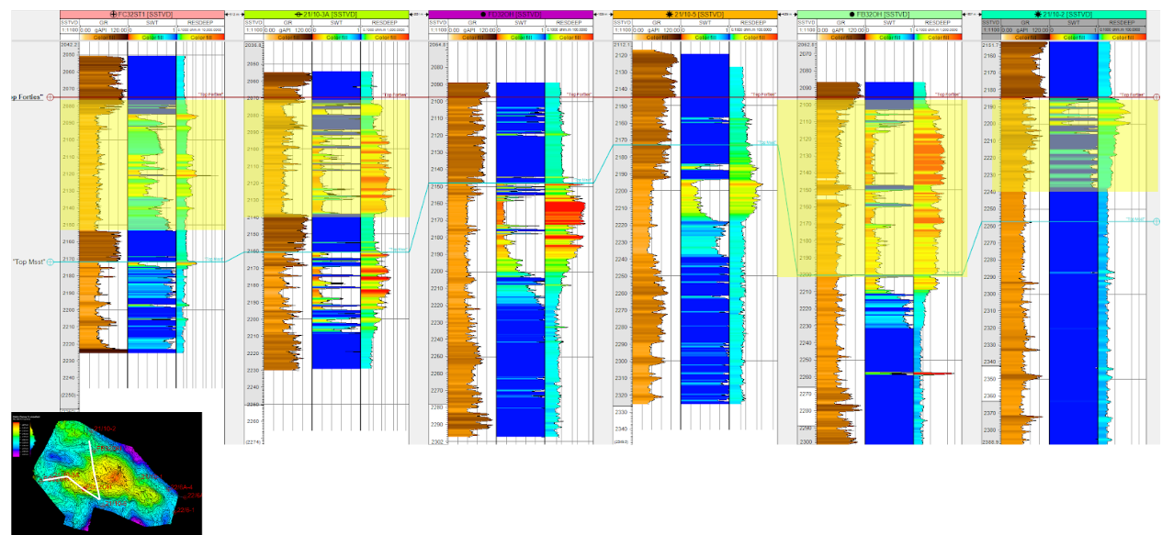

Figure 5: Well Correlation from Northeast to Southwest of Upper Forties Charlie Sand Unit

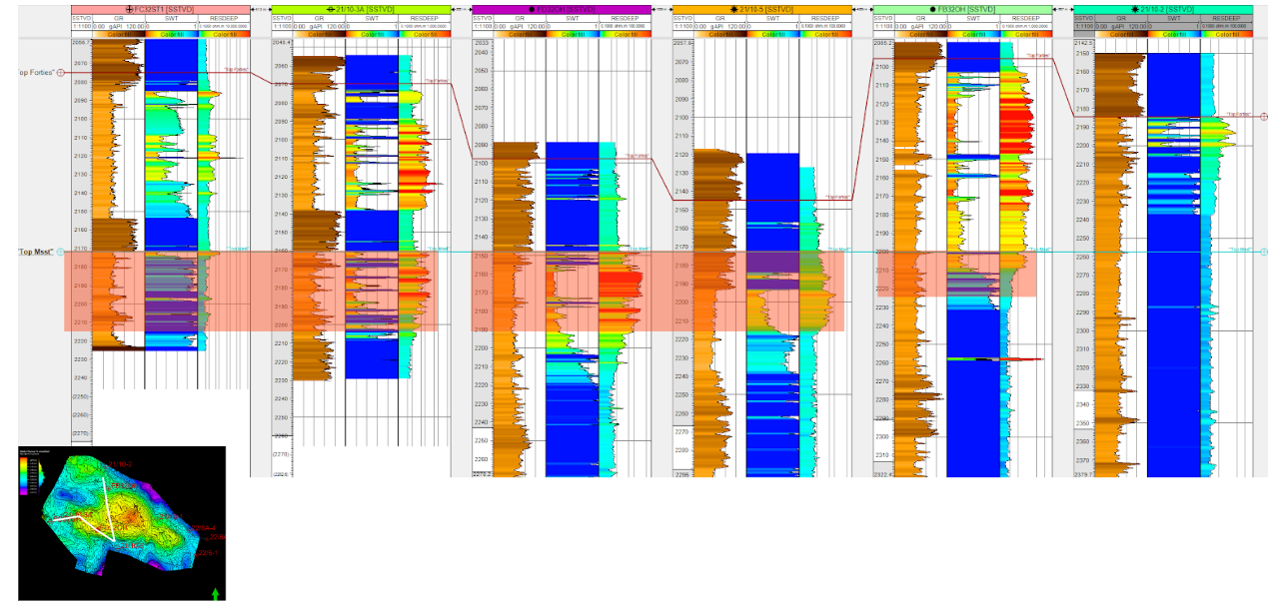

Figure 6: Well Correlation from Northeast to Southwest of Lower Forties Main Sand Unit

The majority of the deep-water Forties field are produced by four-way closure traps where the reservoirs are folded into domes or closed anticlines and where the accumulation is controlled by top seal capacity vs. structural closure relief. Additionally, only approximately 9 % of the Forties field are produced from purely stratigraphic traps which includes channel truncations, lateral pinch-out, channel bends and pinch-out against topographic highs, channel fills, and shale drapes.

* 1. **Reservoir Summary**

Group 3 has decided to produce only from the Charlie Sand of the Forties Sandstone formation in the West area due to the high volume of wells and promising reservoir volume from the preliminary attribute and stratigraphic interpretations seen in Figure 5. The field summary results below are obtained from Shell U.K. Exploration [5].

**Field**: Forties discovered in 1970

**Location**: Central North Sea, UK

**Operators**: British Petroleum Development

**Basin**: Central Graben

**Tectonic/Regional Paleosetting**: Rift basins

**Geologic Structure**: Domal anticline

**Trap Type**: Four-way closure and stratigraphic

**Reservoir - Upper Forties Charlie Sand Unit**

• **Age**: Upper Paleocene

• **Stratigraphic Unit**: Forties Formation

• **Lithology**: Litharenites

• **Depositional Environment**: Submarine fan

• **Productive Facies**: Channel-fill, lobe, and interchannel sandstone

• **Porosity Type**: Primary, intergranular

• **4>**: Average 26%, range 24 to 27%, cutoff 12% (stressed cores)

• **k**: Average 1,000 md, range 500 to 2,000 md, cutoff 1.0 md

• **Sw**: Average 23%, range 22 to 32% (logs)

1. **Reservoir Quality Predictions**
   1. **Volume Attribute Maps**

Several time slices at the depth of Charlie Sand of the 3D volume attributes were created as shown in Figure. 7. The attributes include Coherency, RMS amplitude, Quadrature, and Ant tracking, all mapped for the whole volume of the seismic survey in addition to isochron (thickness map) and time structure maps. A description of each mapped attributes are:

* Coherence compares the similarity between seismic traces and showing discontinuities. It is often used to identify fractures or faults. We can see the pattern of channels in coherency map, which is important since our reservoir was deposited along the channels.
* Amplitude shows porosity and liquid saturation, so the high amplitude spots would indicate hydrocarbon, this helps us decide our area of interest.
* The ant tracking is also used to identify and track faults through 3D seismic volumes. We can see it is nice our area of interest has fewer faults.
* Quadrature attribute is a type of instantaneous attributes, It can show the lithology contrast and bedding discontinuity. There is also higher contrast in our reservoir, which might indicate hydrocarbon.

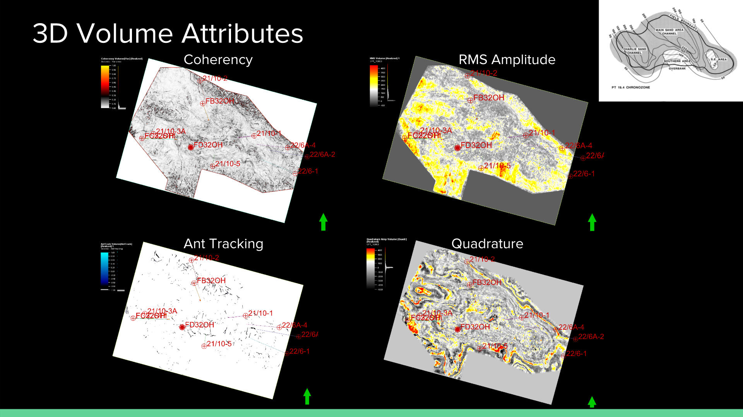

Figure 7 : 3D Volume Attribute Maps (Coherency, RMS Amplitude, Ant Tracking,

and Quadrature Attributes) at Charlie Sandstone time slice interval.

* 1. **Prospect Elements**
     1. **Top Forties Charlie Sand Unit Reservoir**

The Upper Forties Charlie Sand Unit is determined to be the reservoir interval. The Charlie Sand reservoir is from top of Forties Sand to bottom of Charlie Sand (or top of Charlie Shale). As explained in the depositional history, Charlie Sand is one of the main channel deposition thickest interval in Forties. The Charlie Sand reservoir is further interpreted for the structure, thickness and hydrocarbon of formation.

As seen in Figure 8, the Isochron thickness map for Charlie Sand was map from the time structure of the top and bottom of reservoir. This map shows a nice high warm yellow area indicating thick units on the east side of the survey. As seen from the time structure map, the east and middle part of the survey indicates an anticlinal structure, great for structural traps. The coherency map further shows the overall fractures and structure of the reservoir which appears to be fairly continuous in the anticlinal east and west structure. Additionally, the RMS amplitude also shows a high warm in the eastern part of the survey which makes this the area of interest.

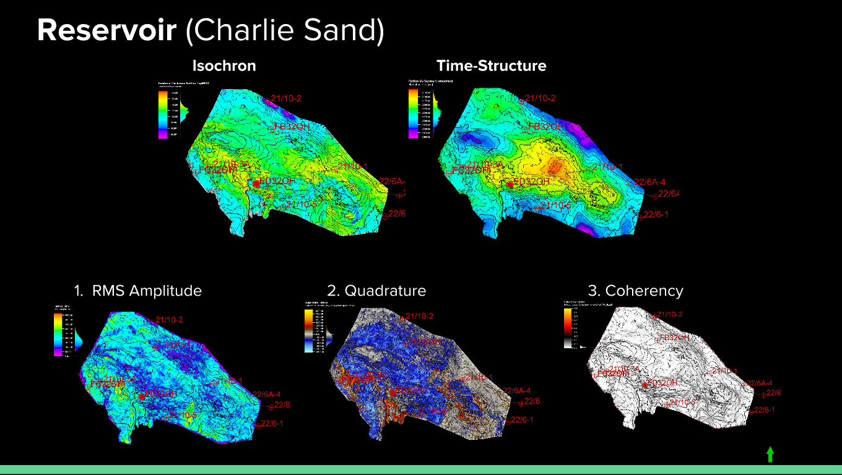

Figure 8 : *Top of Reservoir* of Upper Forties of Charlie Sand Unit: Isochron Thickness Map, Time Structure Map, 1) RMS Amplitude with Time Structure Contour, 2) Quadrature Volume with Time Structure Contour,

and 3) Coherency Volume with Time Structure Contour

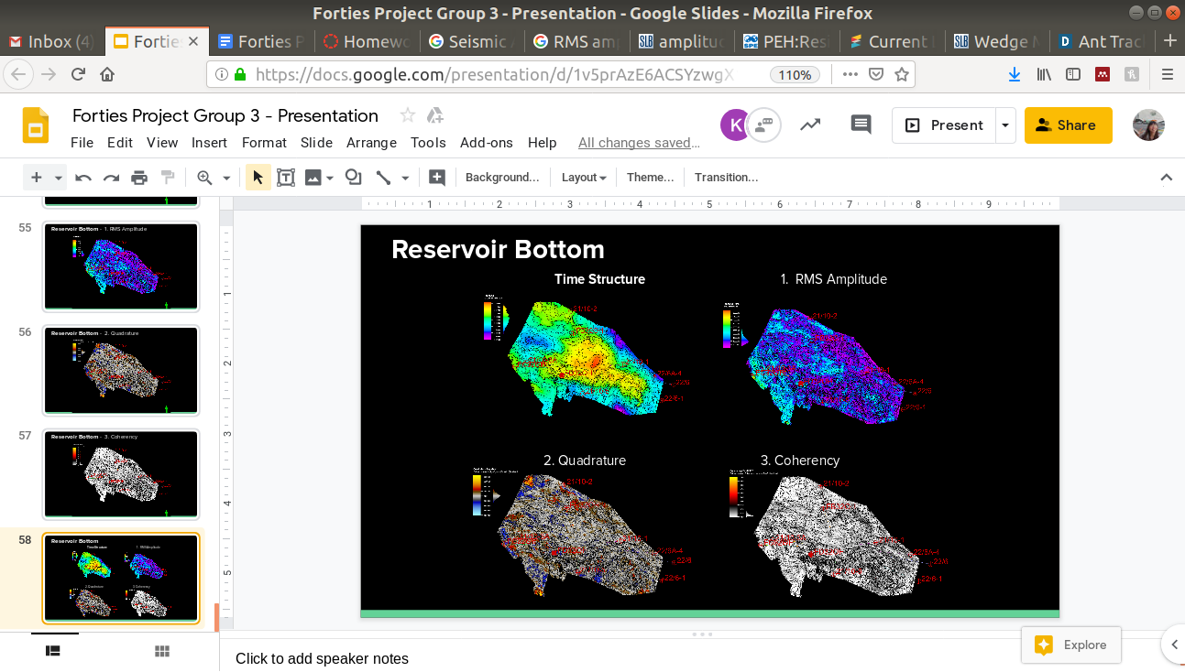

Figure 9 : *Bottom of Reservoir* of Upper Forties of Charlie Sand Unit (or Top of Charlie Shale): Time Structure Map, 1) RMS Amplitude with Time Structure Contour, 2) Quadrature Volume with Time Structure Contour, and 3): Coherency Volume with Time Structure Contour

* + 1. **Balder Seal**

The Balder Seal lies right above the Upper Forties Charlie Sand reservoir interval. As seen in Figure 10, several attribute maps were also made. The same anticlinal structure in the east potential area of the survey seems to be present. From the coherency attribute, the seal also appears to be fairly continuous throughout the area of interest.

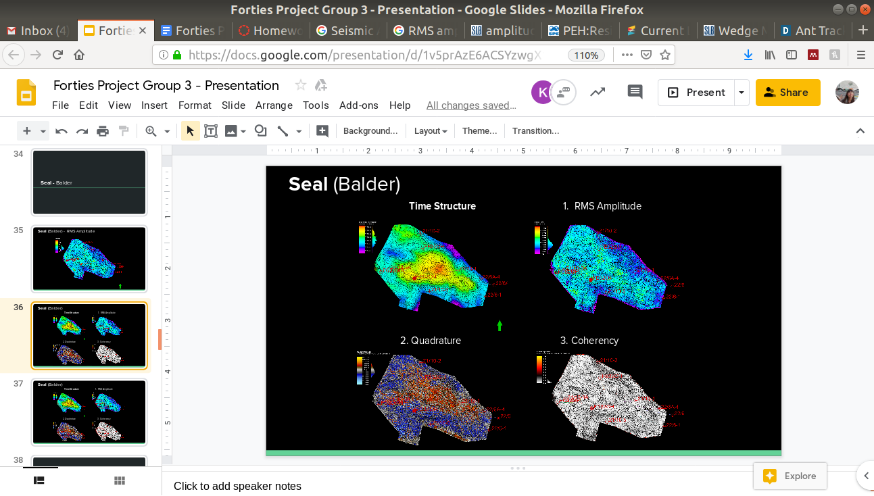

Figure 10 : *Seal* Attribute maps of Balder Unit: Time Structure Map, 1) RMS Amplitude

2) Quadrature Volume, 3): Coherency Volume all with Time Structure Contour

* + 1. **Trap**

The majority of the deep-water Forties field about 66% produces from a combined structural-stratigraphic traps such as four-way closure traps and only approximately 9% of them produce from purely stratigraphic traps [4]. There are several stratigraphic trapping model in the Forties field which includes (1) channel truncations, (2) lateral pinch-out, (3) channel bends and pinch-out against topographic highs, (4) channel fills, and (5) shale drapes as explained in the presentation.

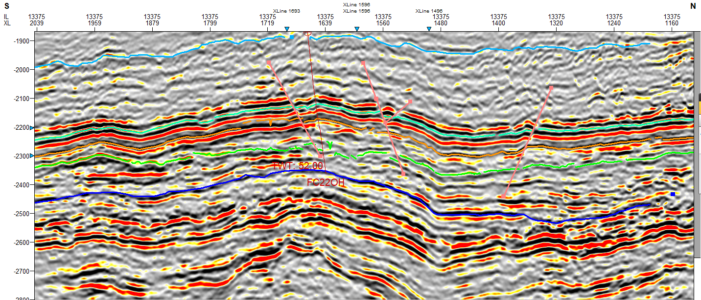

Figure 11: 2D sections through inline directions across the reservoir interval to show the vertical extent and heterogeneity of the reservoir, and key fault interpretation acting on reservoir

* 1. **Field Development Plan and Economic Modeling**

For developing the reservoir the initial production plan would be to start with production wells. Over time as production declines another set of wells would be recommended to rejuvenate production as it has been proven in the past time increase the overall recover factor to 45%-57%. From research it is common to use a number of injection wells for one production well or vice versa. Going this route has the potential to nearly double the recovery factor and production, which makes enhanced recovery method enticing. Using a water flooding method is feasible in the reservoir as it has medium to high permeability and average to above average porosity for sandstone. The high case, P90, has the potential to produce somewhere between 18-30 MMbbl of oil for a net revenue between $1-$1.8 billion. Increasing the area of the reservoir to higher risk areas could potentially increase net revenue to a range of $4-$7 billion based on whether EOR is implemented throughout. Some of the risks in expanding are the potential need to drill more wells in order to produce the much larger area of 700 acres. There is also a system of faults that run outside of the P90 zone that could impede the flow ability of the reservoir using one well. These faults would need to also be considered when drilling any injection wells. The table below list volume and revenue potential for different cases using the original oil in place equation listed below. Some other risk potentials from diverging from the P90 case are that there are some well logs displaying higher water saturations in the Charlie Sandstone formation.

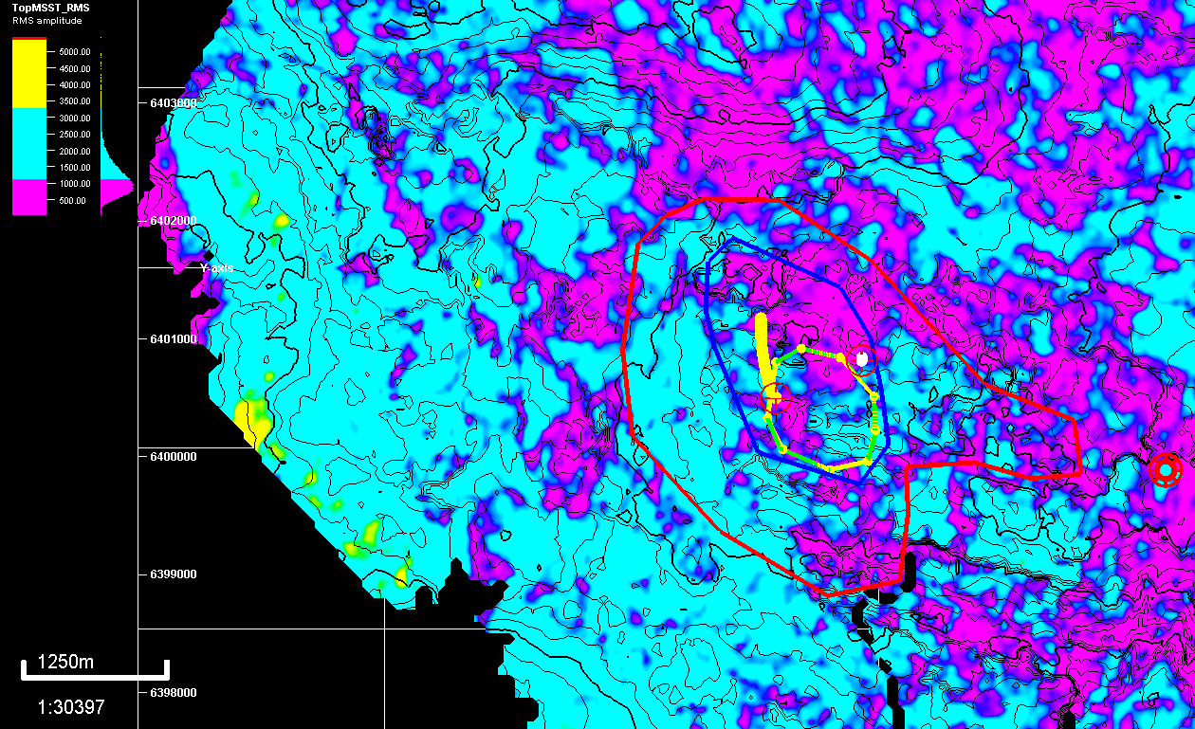

Figure 12: The areas extent for the P90, P50, P10 zones displayed over the RMS model for the bottom of the reservoir as the polygons cut through the Charlie Sand surfaces rendering parts of the polygon as missing pieces.

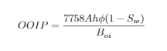

Equation 1: Original Oil in Place (OOIP) in barrels.

|  |  |  |  |  |
| --- | --- | --- | --- | --- |
| **Case** | **OOIP (EOR)** | **OOIP** | **Revenue (EOR)** | **Revenue** |
| P90 | 28MMbbl | 17MMbbl | $1.7B (USD) | $1.0B (USD) |
| P50 | 85MMbbl | 50MMbbl | $5B (USD) | $3B (USD) |
| P10 | 120MMbbl | 70MMbbl | $7B (USD) | $4B (USD) |

Table 1: The varying amount of projected reserves in each case based on recoverable oil using EOR or not, and their associated approximate revenues based on $60/bbl oil price.

1. **Conclusion**

After considering various factors including the geologic framework that went into the creation of the reservoir, the volume attributes and prospect models, and overall assessment of region three regions have been proposed with different risks associated with the each. The production plan proposed for the three cases is to begin working in the P90 regions initially and begin producing. After production starts injection wells should be drilled either one at a time or multiple at once. As production on the first phase begins to decline expansion to the next case should be considered following a similar plan as for P90 region. With the larger regions multiple production wells should be considered as the risk increases for compartmentalization in the reservoir from faulting and pinchouts. Having multiple production wells combined with injections wells should yield high recovery factors as seen in previous results from earlier wells. Considering a water flooding production engineer would also be recommended for maximum returns, and to avoid unnecessary wells and better placement of each well. Taking this route will give the best chances of producing the aforementioned amounts predicted, and will depend on the price per barrel at the time to determine total revenue.

1. **Reference**

[1] GPGN 558: Seismic Interpretation Lecture Notes

[2]“Overview of Seismic Interpretation.” *Robbie Gries: A Career of Many 'Firsts' -*

*AAPG Explorer April 2012,archives.aapg.org/slide_resources/schroeder/9/index.cfm.*

[3] P.J. Hill, “Geology of the Forties Field, U.K. Continental Shelf, North Sea.”

[4] Jose Rodas, “Investigating Stratigraphic Trapping Potential in the Forties Formation,

Palaeocene, UK Central Graben.”

[5] Alexander Kulpecz, “Geological Modeling of a Turbidite Reservoir, Forties Field, North Sea.”

1. **Appendix**

“Wedge modeling is used to investigate and analyze the effects of spatially varying rock parameters and thickness on the seismic signature. The seismic survey geometry is defined and populated by interpolated mapping of measured or modeled well logs—Vs, Vp, and density. Changes in bed thickness are introduced into the model along with changes in acoustic properties determined through rock physics modeling. A synthetic seismic model is generated from the wedge model by applying a range of wavelet and noise attributes. An interactive environment enables direct comparison between modeled and measured response and direct interaction and update of rock physics, bandwidth, and noise attributes.”

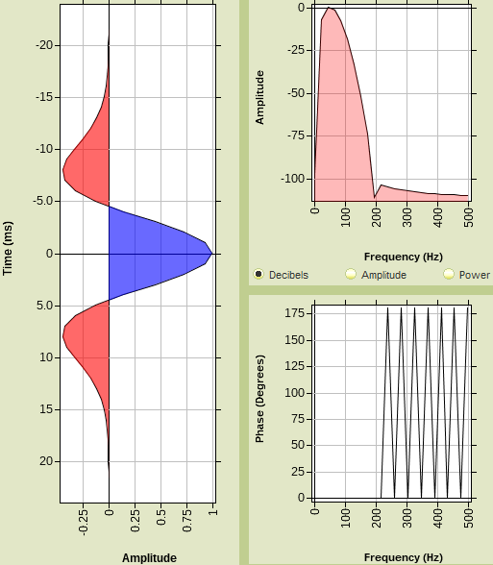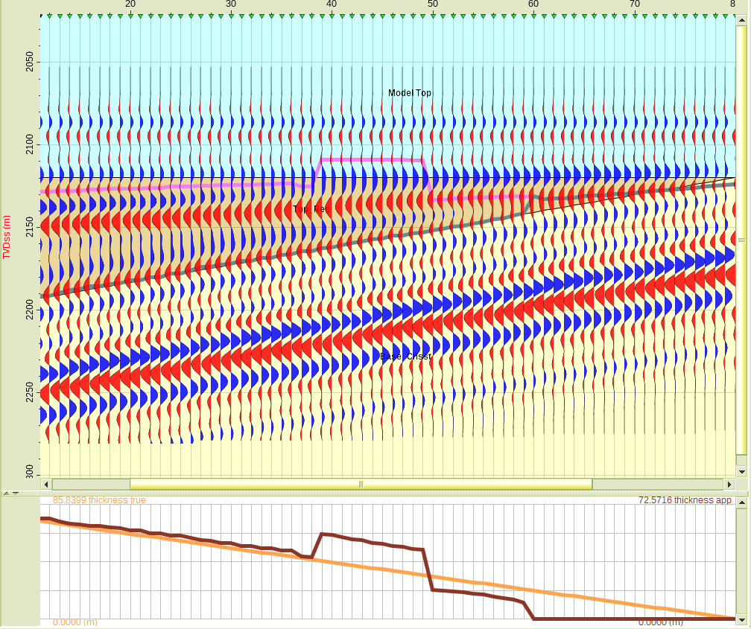

Figure 13: Wedge Model Using Up-Scaled Well Logs

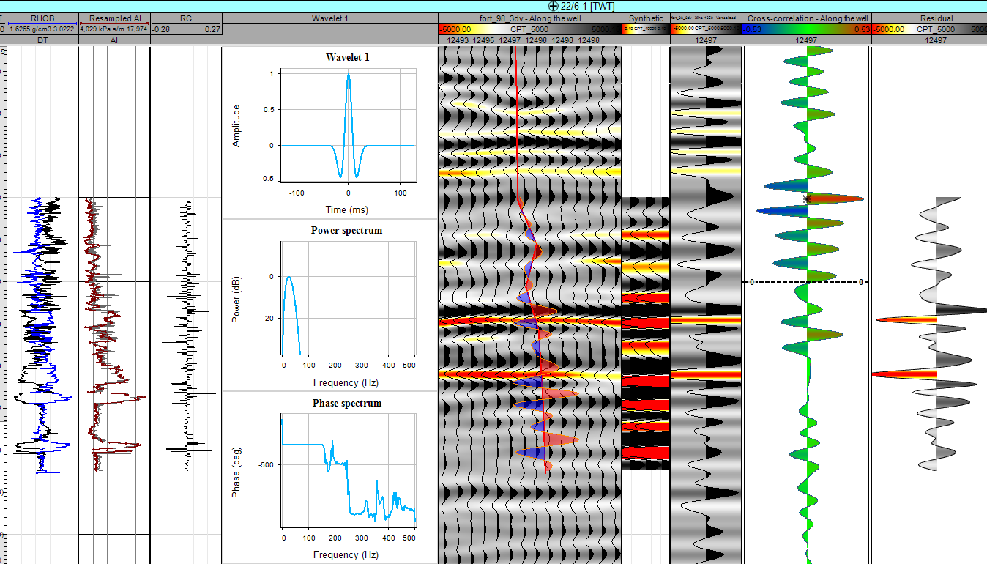

Figure 14: Synthetics in Petrel